**DEPARTMENT OF ELECTRONICS & COMMUNICATION ENGINEERING**



Embedded System

**Experiment-10**

**­­**

**Submitted by**

**PRATIBHA SINGH**

**602162015**

**M.Tech (VLSI Design)**

**­­­**

**Experiment 10**

**Aim**:

To write an ARM Assembly Language to find the factorial of a given 8-bit number.

**Tool Used:**

Keil uVision4

**Theory:**

The numbers in the memory location are repeatedly multiplied and subtracted in an iterative manner.

**Code:**

 AREA PROGRAM, CODE, READONLY

 ENTRY

MAIN

        LDR R0, =0x00001000

        LDRB R1,[R0], #1

        ADDS R1,R1,#0

        BEQ LOOP1

        MOV R2,R1

        SUB R2,R2,#1

LOOP2   MUL R7,R2,R1

        MOV R1,R7

        SUBS R2,R2,#1

        BNE LOOP2

        STRB R1,[R0]

        B LOOP3

LOOP1   MOV R8,#1

        STRB R8,[R0]

LOOP3   B LOOP3

        END

**Output:**

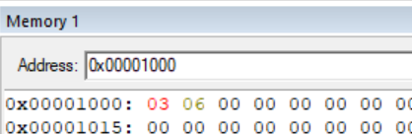

**Result:**

The experiment to find the factorial of a given 8-bit number has been performed and verified to be correct.